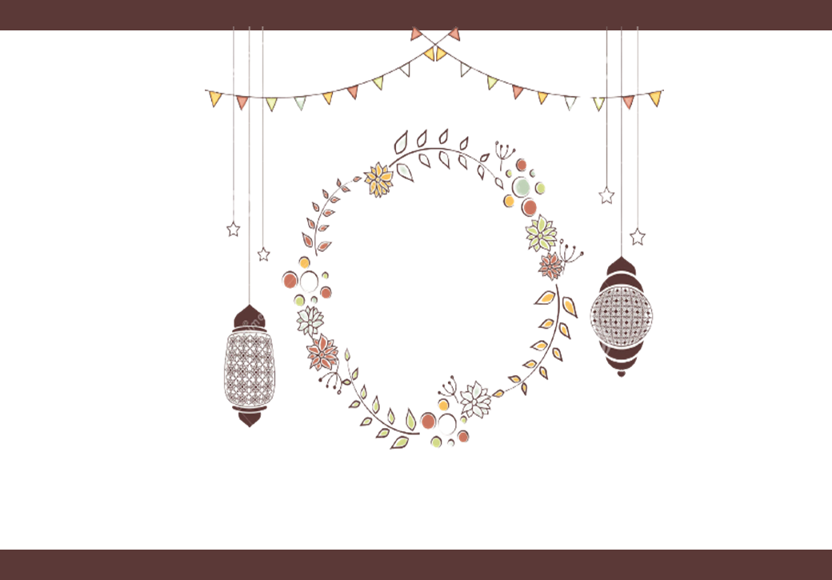

Ramadan

Mubarak

Ingredienten:

Looks 100%

Beauty 100%

Papa 50% Mama 50%

Cuteness 50%

Smart 100%

New born 100%

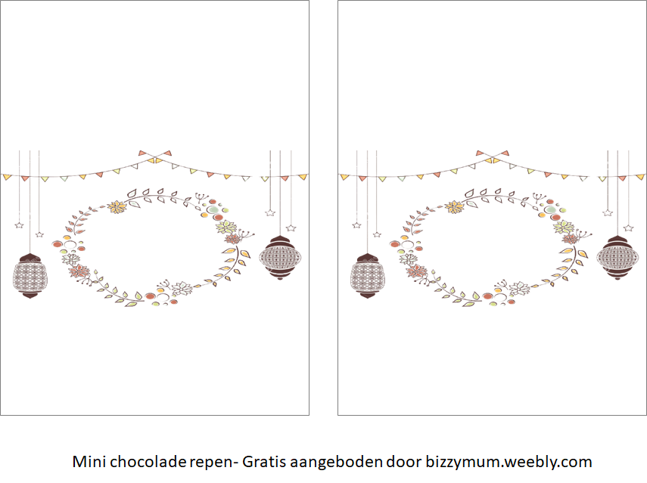

Ramadan

Mubarak

Ramadan

Mubarak

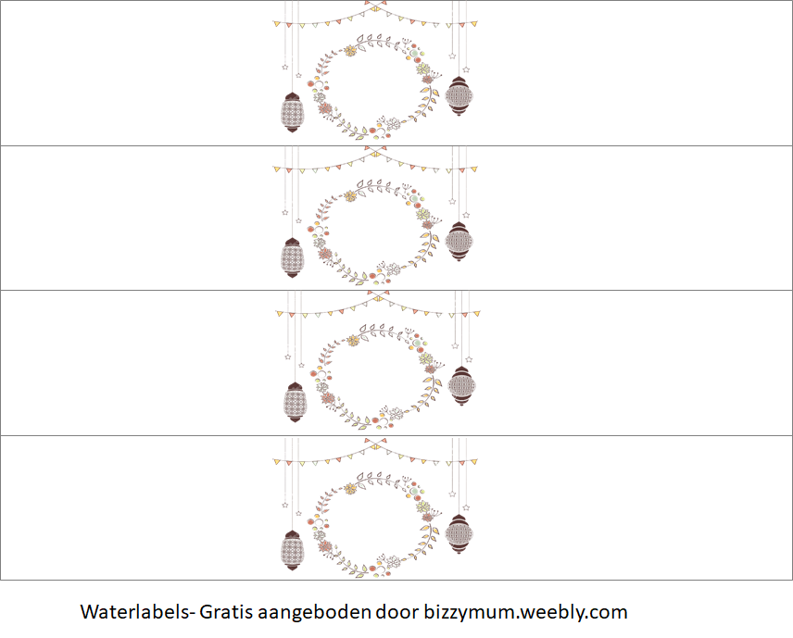

Ramadan

Mubarak

Ramadan

Mubarak

Ramadan

Mubarak

Ramadan

Mubarak

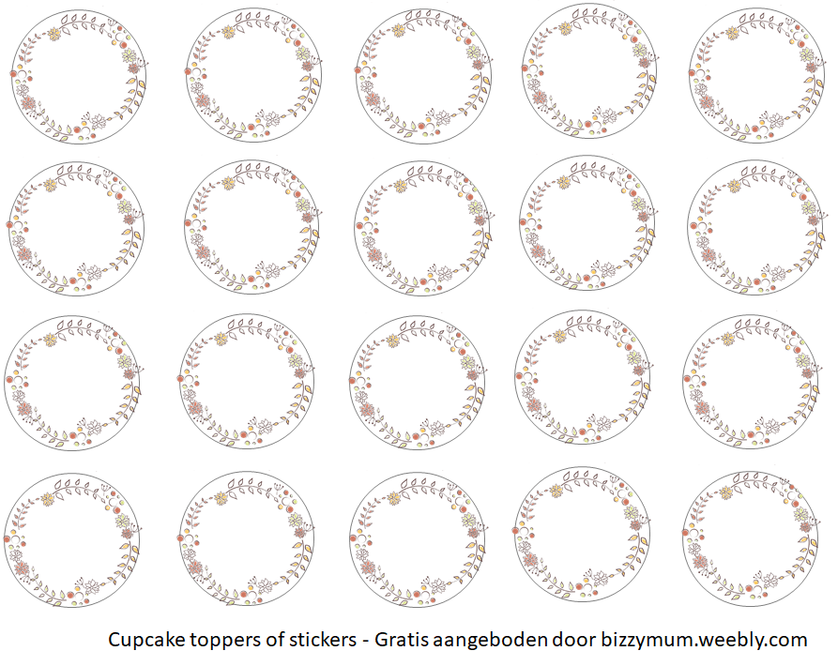

Ramadan

Mubarak

Ramadan

Mubarak

Ramadan

Mubarak

Ramadan

Mubarak

Ramadan

Mubarak

Ramadan

Mubarak

Ramadan

Mubarak

Ramadan

Mubarak

Ramadan

Mubarak

Ramadan

Mubarak

Ramadan

Mubarak

Ramadan

Mubarak

Ramadan

Mubarak

Ramadan

Mubarak

Ramadan

Mubarak

Ramadan

Mubarak

Ramadan

Mubarak

Ramadan

Mubarak

Ramadan

Mubarak

Ramadan

Mubarak

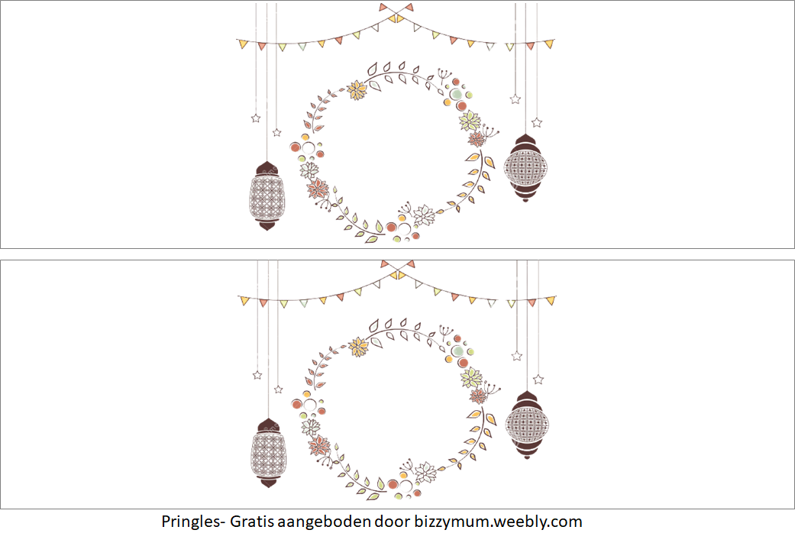

Ramadan

Mubarak

Ramadan

Mubarak

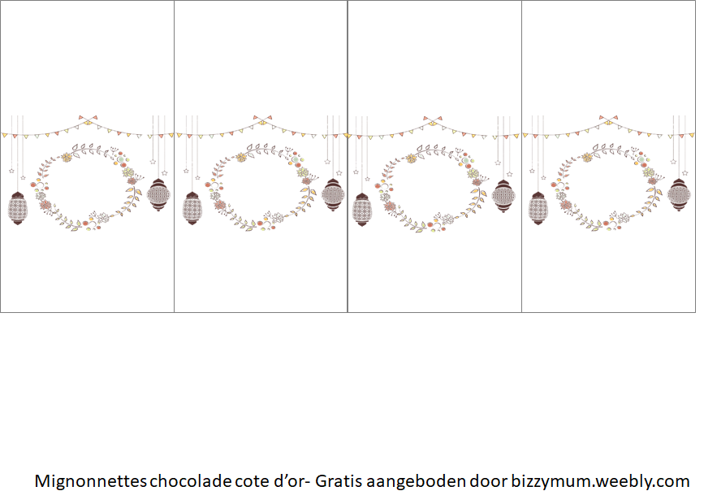

Ramadan

Mubarak

Ramadan

Mubarak

Ramadan

Mubarak

Ramadan

Mubarak

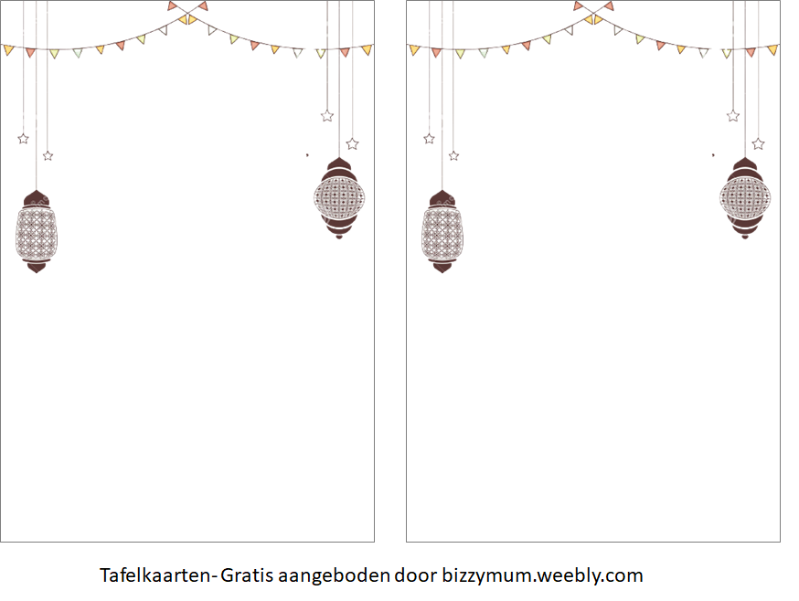

Lorem ipsum dolor sit amet, consectetuer adipiscing elit. Aenean commodo ligula eget dolor. Aenean massa. Cum sociis natoque penatibus et magnis dis parturient montes, nascetur ridiculus mus. Donec quam felis, ultricies nec, pellentesque eu, pretium quis, sem. Nulla consequat massa quis enim.

Ramadan Mubarak

Ramadan Mubarak

Lorem ipsum dolor sit amet, consectetuer adipiscing elit. Aenean commodo ligula eget dolor. Aenean massa. Cum sociis natoque penatibus et magnis dis parturient montes, nascetur ridiculus mus. Donec quam felis, ultricies nec, pellentesque eu, pretium quis, sem. Nulla consequat massa quis enim.



Ramadan

Mubarak

Ramadan

Mubarak

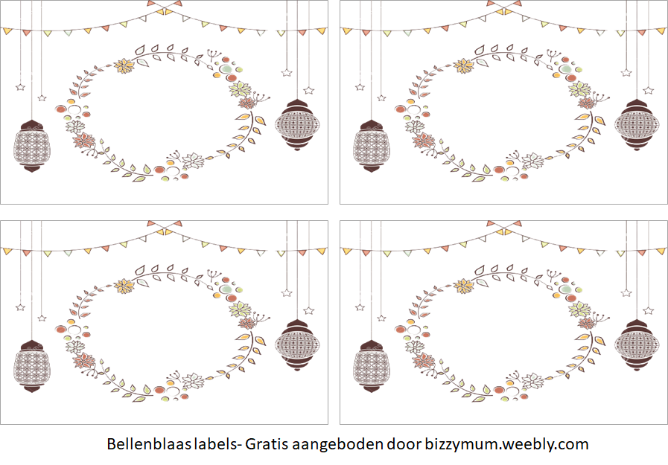

Ramadan

Mubarak

Ramadan

Mubarak

Ramadan

Mubarak

Ramadan

Mubarak

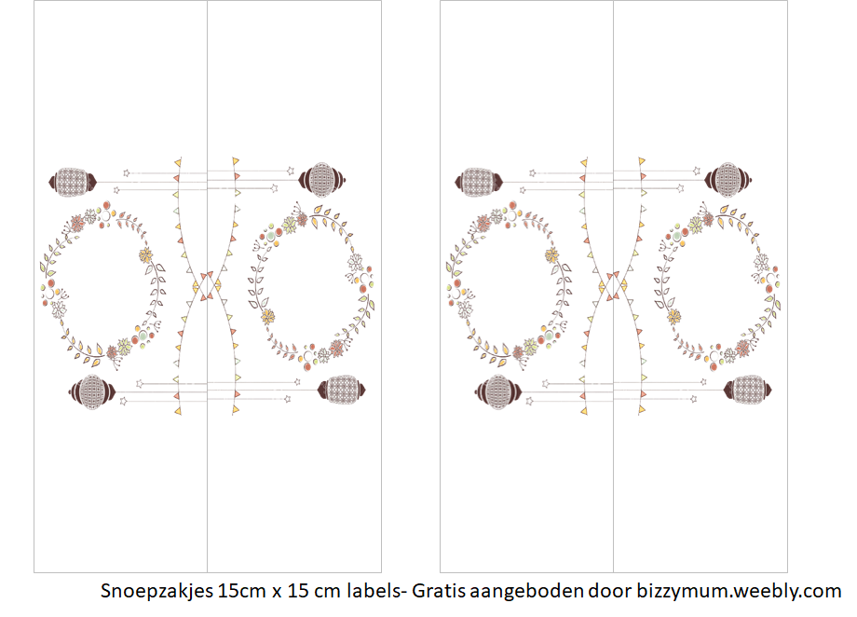

Ramadan

Mubarak

Ramadan

Mubarak

Ramadan

Mubarak

Ramadan

Mubarak