

Ingredienten:

Sabr 100%

Pray 100%

Mosque 50%   
Family 50%

Sadaka 50%

Fasting 100%

Ramadan

Mubarak

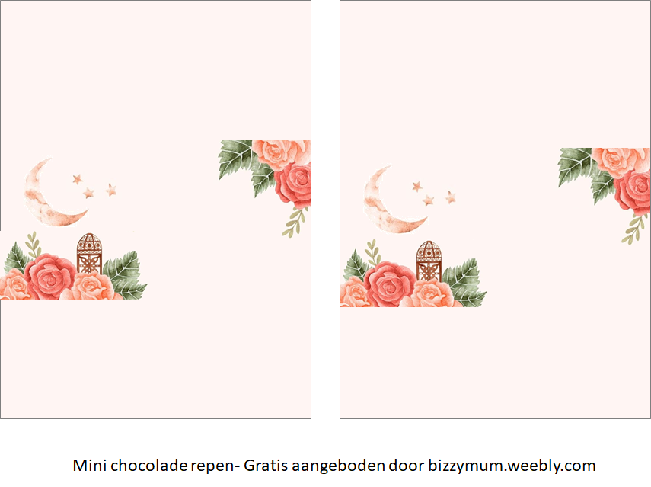

Ramadan

Mubarak

Ramadan

Mubarak

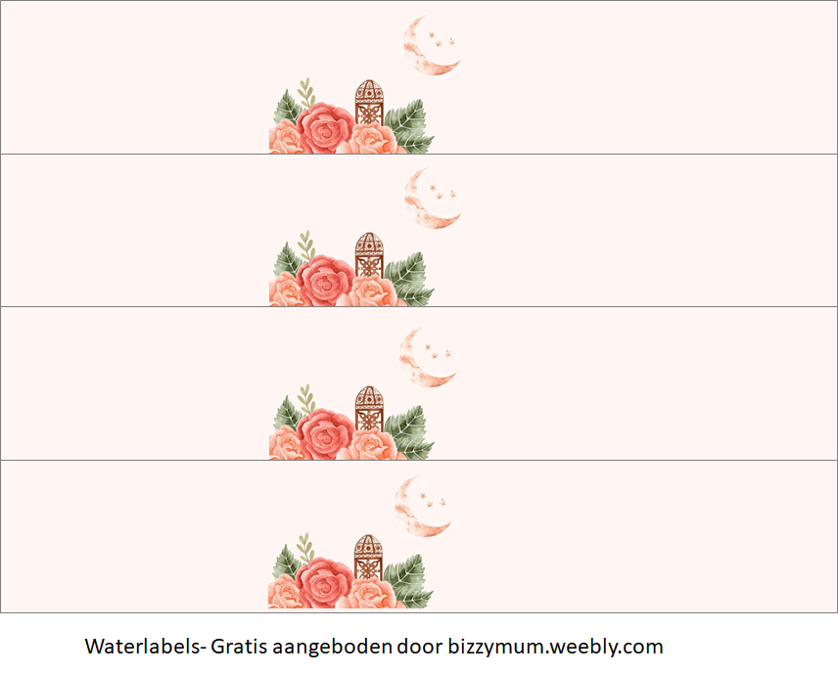

Ramadan

Mubarak

Ramadan

Mubarak

Ramadan

Mubarak

Ramadan

Mubarak

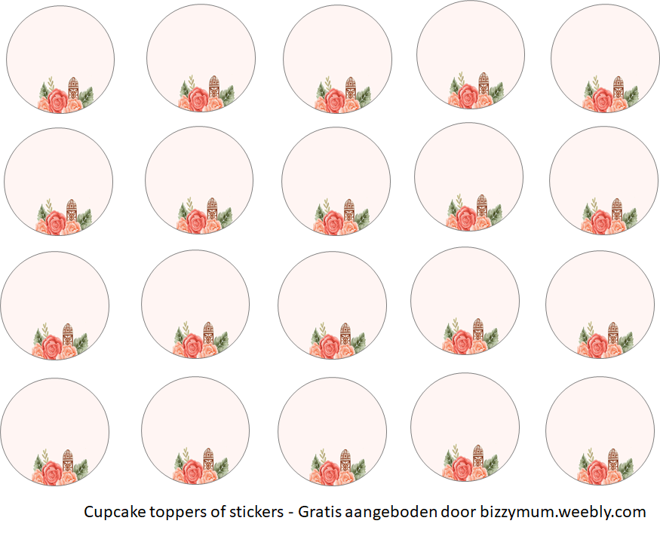

Ramadan

Mubarak

Ramadan

Mubarak

Ramadan

Mubarak

Ramadan

Mubarak

Ramadan

Mubarak

Ramadan

Mubarak

Ramadan

Mubarak

Ramadan

Mubarak

Ramadan

Mubarak

Ramadan

Mubarak

Ramadan

Mubarak

Ramadan

Mubarak

Ramadan

Mubarak

Ramadan

Mubarak

Ramadan

Mubarak

Ramadan

Mubarak

Ramadan

Mubarak

Ramadan

Mubarak

Ramadan

Mubarak

Ramadan

Mubarak

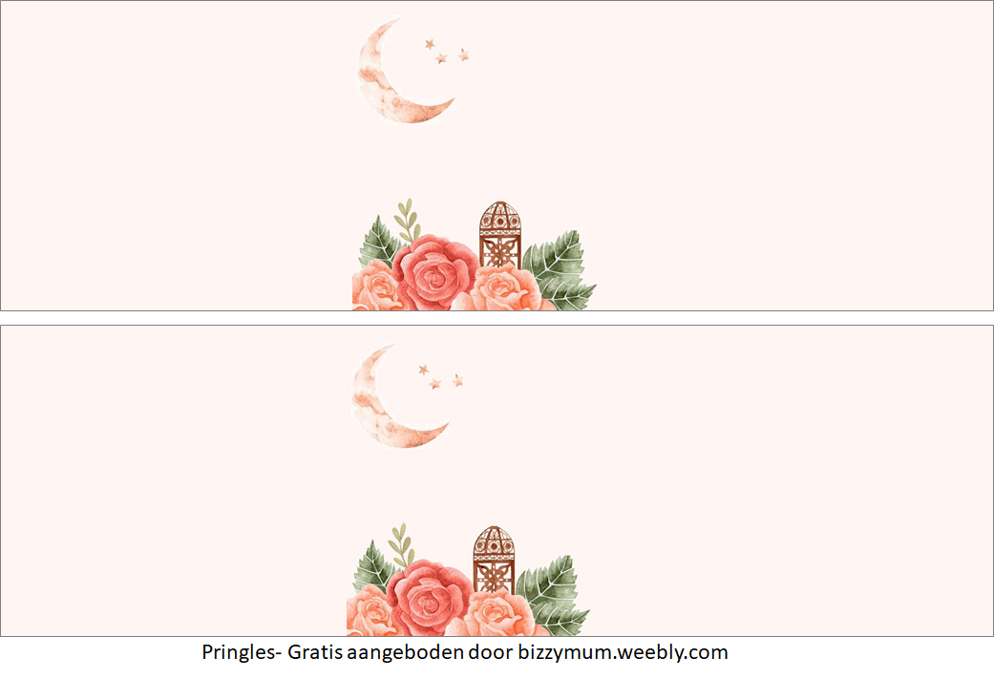

Ramadan

Mubarak

Ramadan

Mubarak

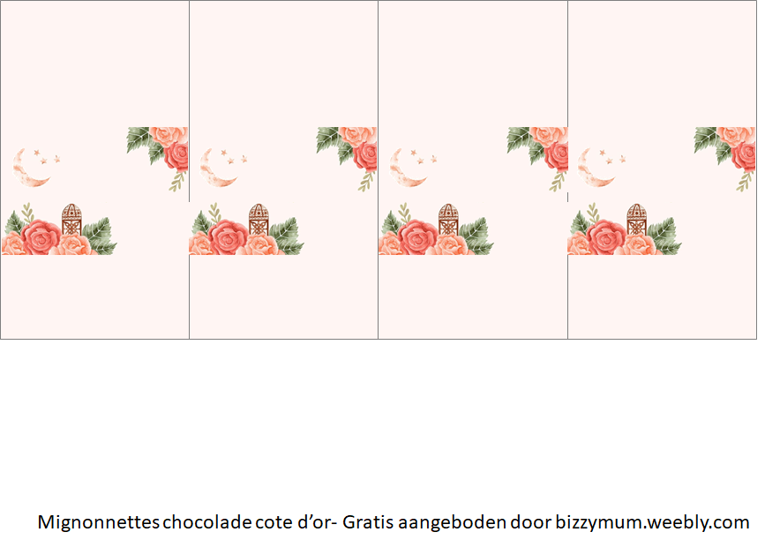

Ramadan

Mubarak

Ramadan

Mubarak

Ramadan

Mubarak

Ramadan

Mubarak

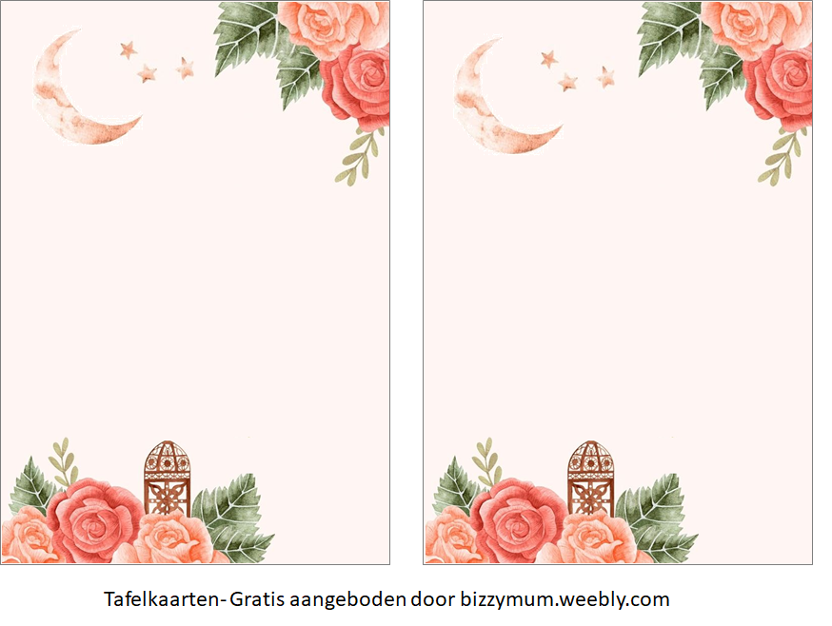

Ramadan Mubarak

Ramadan Mubarak

Lorem ipsum dolor sit amet, consectetuer adipiscing elit. Aenean commodo ligula eget dolor. Aenean massa. Cum sociis natoque penatibus et magnis dis parturient montes, nascetur ridiculus mus. Donec quam felis, ultricies nec, pellentesque eu, pretium quis, sem. Nulla consequat massa quis enim.

Lorem ipsum dolor sit amet, consectetuer adipiscing elit. Aenean commodo ligula eget dolor. Aenean massa. Cum sociis natoque penatibus et magnis dis parturient montes, nascetur ridiculus mus. Donec quam felis, ultricies nec, pellentesque eu, pretium quis, sem. Nulla consequat massa quis enim.



Ramadan

Mubarak

Ramadan

Mubarak



Ramadan

Mubarak

Ramadan

Mubarak

Ramadan

Mubarak

Ramadan

Mubarak

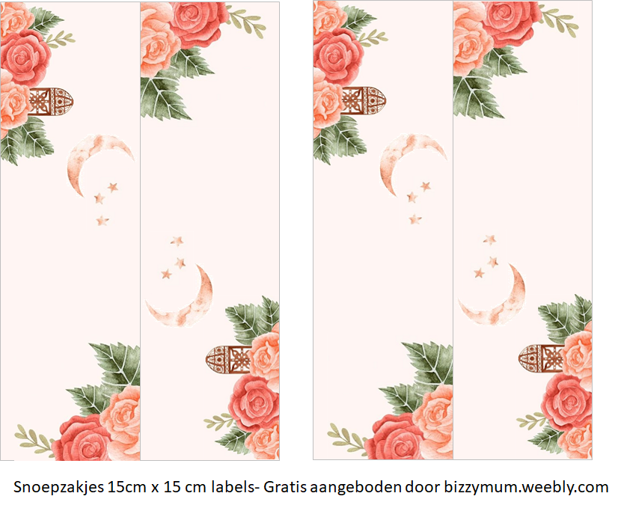

Ramadan

Mubarak

Ramadan

Mubarak

Ramadan

Mubarak

Ramadan

Mubarak